Date:
Company:
Contact person:
Contact information:
Tel:
Fax:
Email:
Address:
Please, return this form to powersales@wtc.com.au
RFI Ver 3.1 WTC
© 2011 GridON Ltd. All rights reserved.

Request for Information

3-phase Fault Current Limiter

Introduction
This form has been prepared to simplify the process of gathering sufficient data for GridON to be able to specify a Fault Current Limiter (FCL) suitable to your needs. The information provided here will enable GridON to perform a preliminary FCL design that fits your exact requirements, and follow-up with detailed discussions.
Please provide the following information:
- One or more scenarios where prospective fault currents exceed or approach your equipment capability. To simplify this process, we have provided 3 examples.
- What you have been doing so far to overcome prospective fault currents on your grid
- A detailed single line diagram, along with description of operating arrangements
- Load profile of different operating/running arrangements

Application Example 1 - Generator Feeder scenario:
Assume a typical distribution substation with 15 kV rated voltage and two 30MVA (16% impedance (Uk)) transformers, with all equipment designed and built to sustain fault current level up to 20kA. To support increasing load, a 30MW (with 16% X_{d}”) generator is designed in. This will increase the prospective fault current level across the substation above its breaking limits.

Application Example 2 - Bus-tie scenario:
For the same distribution substation (with15kV and maximum 20kA prospective fault current), the two 30MVA transformers need to be changed to 50MVA (17.5% U_{K}), preferably without changing any other equipment.

Application Example 3 – Transmission substation with FCL on outgoing feeder
A typical transmission substation with 220kV rated voltage, two 400/220kV transformers and 5 overhead line feeders. Fault levels exceed the equipment rating, and an FCL is designed in to reduce the fault level to 35kA which is the maximum allowed level for this substation.

Possible solution for these 3 examples (without FCL):
Splitting the substation network into two independently operating segments (with an open CB in bus-tie), or alternatively, upgrading the substation equipment (including CB) to sustain 30kA prospective fault current rating.

Customer: substation/network case(s) with extensive fault currents

Customer: what solutions are currently used to overcome fault current?

Single Line Schematics
Below are high level schematics for the 3 application examples described above.

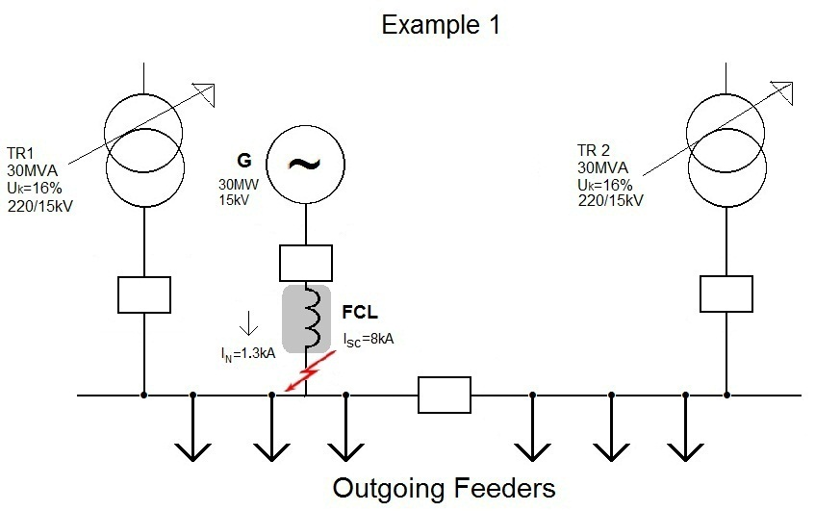
Application Example 1 - Generator Feeder connection:

The prospective fault current (I_{SCP}) from each transformer is 7.2 kA. The prospective fault current added by the new generator is 8 kA, hence increasing the overall substation fault current, above the breaking limit, to 22.4 kA. An FCL is installed at generator feeder point, and is designed with insertion impedance of 0.27 Ω (ε=4% voltage drop on the FCL) during normal operation. The FCL impedance may increase up to 1.62 Ω during fault, reducing the generator fault current by 60% to maximum 3.2 kA; hence prospective fault current across the substation will be kept under 18 kA.

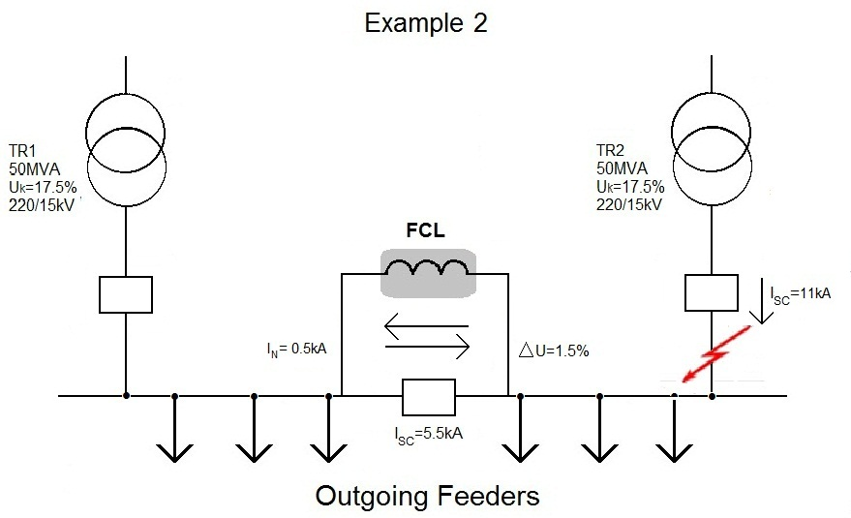
Application Example 2 - Bus-tie connection:

By upgrading the transformers to 50MVA (17.5% Uk), the prospective fault current from each transformer will increase to 11 kA; exceeding the total 20 kA allowed in the substation. The FCL is installed at bus-tie connection (in parallel to the circuit breaker), and its nominal current is based on a 25% unbalanced nominal load between the two transformers; hence, nominal current flowing through the FCL is ~500A. Designing the FCL with impedance of 0.26 Ω (ε=1.5% voltage drop on the FCL) during normal operation, and maximum impedance of 0.8 Ω during fault, the FCL will reduce the prospective fault current flowing through it by 50% to maximum 5.5 kA; hence fault current across the substation will be kept under 16.5kA.

Application Example 3 – Transmission substation – OHL feeder

Overall fault level on the bus-ring is 41kA - exceeding the maximum capacity of 35kA.
The 475 MVA FCL is installed on the OHL feeder with the largest contribution of fault current to the bus-ring. It is designed with 60% clipping – to reduce line E fault contribution from 10kA to 4kA. With this reduction of line E contribution, the fault level on the bus-ring is limited to below 35kA (with the FCL in service).

Customer Schematics (please provide your single line schematic(s) in the designated area below or in an attached document):
Please include single line schematic(s) of the relevant grid segments and/or substations where you are most concerned with prospective fault current exposure.
Please describe different operating arrangements of your grid (e.g. normally operating with bus-section open, and upon failure of one transformer – closing bus section and run from remaining transformers).
Please indicate your initial thoughts or preference for possible FCL location(s) on your current grid.
Please specify which equipment in your grid dictates the maximum allowable fault current.
Please show the contributions of fault current from each segment of the single line diagram into the fault location.

Grounding Method
Please describe the grounding method used in your Grid (solid, Petersen coil, earthing transformer, resistor etc.) with as much detail as possible.

Customer expected/required outcomes (with FCL installed):

Load Profile for FCL location
Please fill in the following table for the FCL suggested location. If possible, attach also as a curve:
 | Current through FCL location [kA] | Annual working hours in this condition [Hours] | Does this operating condition require fault current limitation? [Y/N] | Comments
Maximum continuous current
75% of maximum continuous current
50% of Maximum continuous current
25% of maximum continuous current
Annual average load current

Technical Specifications
Below please find Technical Data relating to our two examples. Please add your specific data in the last column. GridON will use this data to specify an FCL and key performance parameters, which will help in further discussions.

Technical Data | Example1 | Example 2 | Example 3 | Customer Data
Nominal Voltage on the grid/substation (in kV):
Line to Line (V_{L}): | 15 kV | 15 kV | 220 kV | ___ kV
Line to Ground (V_{PH}): | 8.66 kV | 8.66 kV | 127 kV | ___ kV
Transformers ratings (of the transformers currently installed):
Number of transformers in the substation/grid-segment | 2 | 2 | 2 | ____
Primary/Secondary Voltage (kV) | 220/15kV | 220/15kV | 400/220 kV | ___ kV
Rated (ONAN) power of one transformer (MVA) | 30 MVA | 50 MVA | 600 MVA | ___ MVA
Transformer Impedance (Uk) | 16% | 17.5% | 11.5% | ___ %
Transformer regulation range and tap steps:  (please include transformer R&D plate if possible) | +4.3% to -15.7%, 14 steps | +4.3% to -15.7%, 14 steps | N.A. | _____
Maximum Overall Fault Current in the grid segment / substation (in kA):
Prospective Fault Current without FCL installed | 22.4 kA | 22 kA | 41 kA | ___kApeak/  ____kArms
Expected Limited Fault Current with FCL installed | 17.6 kA | 16.5 kA | 35 kA | ___kApeak/  ____kArms
Nominal and Overload Current, expected to flow through the FCL (in kA):
Nominal | 1.3 kA | 0.5 kA | 1.25 kA | ___ kA
Overload | 1.5 kA | 0.6 kA | 1.4 kA | ___ kA / ___Hrs
Grid characteristics at the FCL connection point (without FCL):
X/R ratio | 14 | 12 | 11 | _____
Acceptable voltage drop during normal operation (in %):
- maximum allowed voltage drop on the FCL during normal operation, measured as portion of the line to neutral voltage (% of V_{PH})
Maximum allowed voltage drop on the FCL: | 4% | 1.5% | 4% | ___ %
Prospective fault current through the FCL location (without FCL installed)
Prospective fault current through the FCL location | 8 kA | 11 kA | 10 kA | ___ kA
Required limited current through the FCL during fault condition (in kA):
Limited Fault Current through the FCL: | 3.2 kA | 5.5 kA | 4 | ___ kA
Additional Parameters
Lightning impulse level for which the FCL should be tested: | 75kV | 75kV | 950 kV | ____kV

Customer Comments/Requests:

Wilson Transformer Company: 310 Springvale Road (PO Box 5), Glen Waverley, Victoria, 3150, Australia
T: +61 (0) 3 9560 0411 / +61 (0) 3 9560 0499 / powersales@wtc.com.au / www.wtc.com.au
RFI Ver 3.1 WTC
© 2011 GridON Ltd. All rights reserved.

Please specify for each fault location or scenario if relevant (e.g. fault location relative to the FCL location in the grid
Specify both peak make fault level and steady state fault level
Specify desired limited peak make fault level and steady state fault level
Please specify overload duration
X/R ratio of the short-circuit Thevenin impedance at the point where the FCL would be connected
Please mark (on the line diagram) fault current contribution of each contributing element in the grid into the FCL location
This will be the fault current with the FCL in circuit

